BACKEND DEVELOPMENT
AI FAQ ASSISTANT API
PROJECT DOCUMENT

Team ID | SWTID-2026-5192
Team Size | 4
Project Topic | AI FAQ Assistant API
Technology | Node.js • Express.js • MongoDB
Project Type | Backend Development

Project Team
Role | Name | Email ID
Team Leader | Lithika MS | lithikamurali3@gmail.com
Team Member 1 | Madhumitha D | dkmadhumitha20122006@gmail.com
Team Member 2 | Monisri N | monisriii.sdm123@gmail.com
Team Member 3 | Nisha S | nishasuresh1003@gmail.com

Submitted as a backend development project demonstrating a RESTful API for managing and retrieving frequently asked questions using Node.js, Express.js and MongoDB.

BACKEND DEVELOPMENT
AI FAQ ASSISTANT API

1. Introduction
The AI FAQ Assistant API is a backend service designed to provide fast, structured answers to frequently asked questions. It exposes REST API endpoints that can be consumed by a web application, mobile application, chatbot, or other client.

Objectives
- Create a secure and maintainable REST API for FAQ management.
- Store FAQ questions, answers and categories in MongoDB.
- Provide search and retrieval endpoints for client applications.
- Keep the backend modular so an AI answer-generation component can be integrated later.
- Return consistent JSON responses and HTTP status codes.

Technology Stack
Technology | Purpose | Example
Node.js | JavaScript runtime | Server execution
Express.js | Web framework | REST endpoints
MongoDB | NoSQL database | FAQ storage
Mongoose | ODM | Schema and database operations
Postman | API testing | Request/response testing

System Flow
Client → Express API → Route/Controller → Mongoose Model → MongoDB → JSON Response

PROJECT CODE LINK:
https://drive.google.com/drive/folders/19_y5jh21WPbohCj2KJ3lT9J73TRN18zh?usp=drive_link
DEMO DRIVE LINK:
https://drive.google.com/drive/folders/1q3h4UHFVWRgc1n6dsb2eB359xmvfWmlk?usp=drive_link

BACKEND DEVELOPMENT
AI FAQ ASSISTANT API

2. Backend Architecture
The backend follows a simple layered structure. Routes receive HTTP requests, controllers handle application logic, models communicate with MongoDB, and middleware performs common processing such as JSON parsing and error handling.

Suggested Folder Structure
ai-faq-assistant/
├── server.js
├── package.json
├── .env
├── models/
│ └── FAQ.js
├── routes/
│ └── faqRoutes.js
├── controllers/
│ └── faqController.js
└── middleware/
└── errorHandler.js

FAQ Data Model
const mongoose = require('mongoose');
const faqSchema = new mongoose.Schema({
question: { type: String, required: true, trim: true },
answer: { type: String, required: true },
category: { type: String, default: 'General' },
tags: [{ type: String }]
}, { timestamps: true });
module.exports = mongoose.model('FAQ', faqSchema);

Database Connection
mongoose.connect(process.env.MONGO_URI)
.then(() => console.log('MongoDB connected'))
.catch(err => console.error('Database error:', err));

BACKEND DEVELOPMENT
AI FAQ ASSISTANT API

3. API Implementation and Coding
The following example implements core FAQ endpoints. The API accepts JSON requests and responds with JSON data.
const express = require('express');
const mongoose = require('mongoose');
const FAQ = require('./models/FAQ');
const app = express();
app.use(express.json());
app.get('/api/faqs', async (req, res) => {
try {
const faqs = await FAQ.find().sort({ createdAt: -1 });
res.json({ success: true, data: faqs });
} catch (error) {
res.status(500).json({ success: false, message: 'Server error' });
}
});
app.post('/api/faqs', async (req, res) => {
try {
const faq = await FAQ.create(req.body);
res.status(201).json({ success: true, data: faq });
} catch (error) {
res.status(400).json({ success: false, message: error.message });
}
});
app.listen(5000, () => console.log('API running on port 5000'));

Search Endpoint
app.get('/api/faqs/search', async (req, res) => {
const q = req.query.q || '';
const results = await FAQ.find({
$or: [
{ question: { $regex: q, $options: 'i' } },
{ answer: { $regex: q, $options: 'i' } },
{ tags: { $regex: q, $options: 'i' } }
]
});
res.json({ success: true, count: results.length, data: results });
});

The search route supports case-insensitive matching across questions, answers and tags, making it suitable for FAQ lookup before adding an AI semantic-search layer.

BACKEND DEVELOPMENT
AI FAQ ASSISTANT API

4. API Testing and Screenshots
The API can be tested using Postman or any REST client. The screenshots below represent sample development-time API interactions.

Screenshot 1 — Server Code
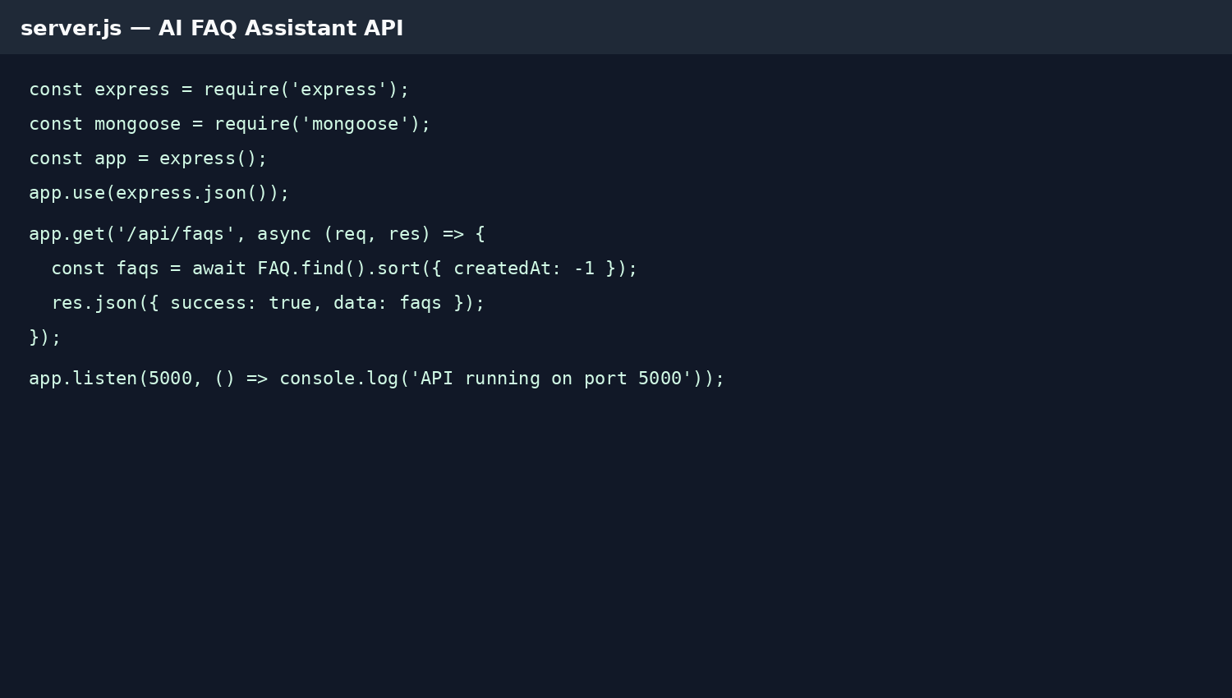
Figure 1: Example Node.js/Express backend implementation.

Sample POST Request
POST /api/faqs
Content-Type: application/json
{
"question": "How do I reset my password?",
"answer": "Use the Forgot Password option and follow the email instructions.",
"category": "Account",
"tags": ["password", "account"]
}

BACKEND DEVELOPMENT
AI FAQ ASSISTANT API

5. API Response and Database

Screenshot 2 — GET /api/faqs Response
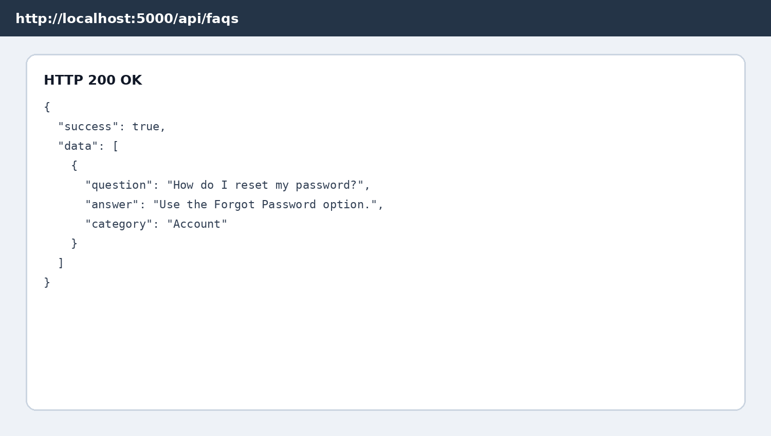
Figure 2: Sample successful JSON response returned by the FAQ API.

MongoDB Collection
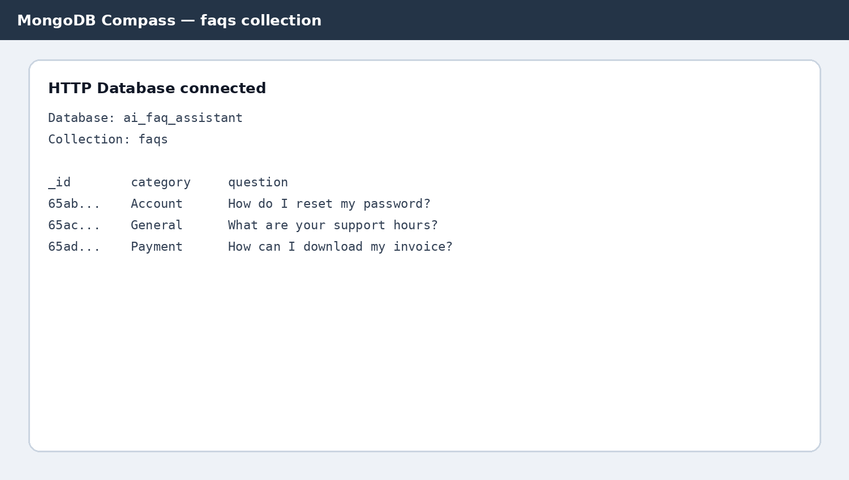
Figure 3: Example FAQ documents stored in the MongoDB collection.

PROJECT CODE LINK:
https://drive.google.com/drive/folders/19_y5jh21WPbohCj2KJ3lT9J73TRN18zh?usp=drive_link
DEMO DRIVE LINK:
https://drive.google.com/drive/folders/1q3h4UHFVWRgc1n6dsb2eB359xmvfWmlk?usp=drive_link

BACKEND DEVELOPMENT
AI FAQ ASSISTANT API

6. Security, Error Handling and Future Scope

Security Considerations
- Store MongoDB credentials in environment variables instead of source code.
- Validate request fields before inserting documents.
- Use authentication and authorization for administrative FAQ operations.
- Apply rate limiting and security middleware such as Helmet in production.
- Avoid returning sensitive server or database details in error responses.

Error Handling
app.use((err, req, res, next) => {
console.error(err);
res.status(500).json({
success: false,
message: 'Internal server error'
});
});

Future Enhancements
- AI-powered semantic FAQ matching using embeddings.
- Natural-language question answering with an AI model.
- Admin dashboard for creating and updating FAQs.
- JWT-based authentication for protected endpoints.
- Analytics for unanswered questions and frequently searched topics.
- Deployment using a cloud hosting platform with managed MongoDB.

Conclusion
The AI FAQ Assistant API provides a practical backend foundation for an intelligent FAQ system. Node.js and Express.js handle API communication while MongoDB stores flexible FAQ data. The modular structure allows future integration of AI-based retrieval and answer generation without redesigning the entire backend.

END OF PROJECT DOCUMENT

